6 Recommended Focus Areas

How Many Focus Areas?
Never more than 4

No significant strain
Show:

1–2 Areas for Reflection

Moderate strain
Show:

2–3 Areas for Reflection

Significant strain
Show:

3–4 Areas for Reflection

How Are Focus Areas Generated?
This is important.
I would NOT generate them directly from:
Highest domain = Burnout
Instead:
Highest domain
+
Contributing themes
+
Interaction pattern

Example

High Burnout
Could produce very different focus areas.

Profile A
Burnout driven by:
- workload
- recovery
Focus Area:

Restoring Capacity
Your results suggest that current demands may be outpacing opportunities for recovery. Reflecting on how energy is restored, protected, and allocated may help clarify where strain is accumulating.

Profile B
Burnout driven by:
- authenticity
- conformity
Focus Area:

Reducing the Cost of Adaptation
A significant portion of your effort may be directed toward adapting to environmental expectations. Exploring where greater flexibility or authenticity is possible may help reduce unnecessary strain.

Same domain.
Different focus.

The Structure I Would Use
Each focus area gets:

Title

Why This Matters

Reflective Question

Example:

Reducing the Cost of Adaptation

Why This Matters
Your results suggest that maintaining alignment with your environment may require ongoing adjustment in how you present, communicate, or work. While this can be effective, it may also contribute to fatigue if sustained over long periods.

Reflective Question
Where do you feel most able to operate naturally, and where do you feel most required to adapt?
This is much stronger than:
"Try to be more authentic."

For the Cultural Strain Profile

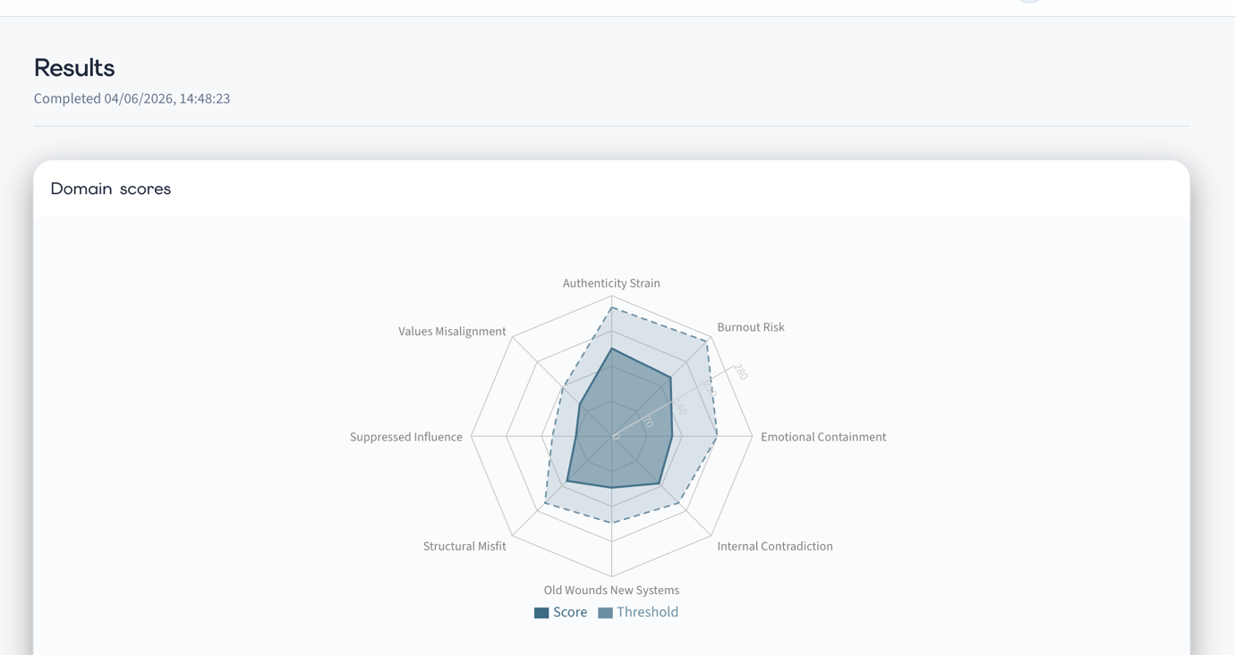
I might generate:

Reducing the Cost of Adaptation

Why This Matters
A substantial proportion of the strain identified in your results appears linked to the effort required to align with environmental expectations.

Reflective Question
Which aspects of your current role feel natural, and which feel effortful to maintain?

Protecting Energy and Recovery

Why This Matters
The profile suggests that demands may be accumulating more quickly than opportunities for recovery.

Reflective Question
What activities, relationships, or environments consistently restore energy, and how available are they within your current routine?

Evaluating Environmental Fit

Why This Matters
The assessment suggests that some of the strain may arise from the relationship between you and the system, rather than from any lack of capability or motivation.

Reflective Question
If the environment changed but you remained the same, which of your current challenges would likely disappear?

Should the LLM Generate These?
Yes.
But not from raw scores.
The engine should provide:
{
"focus_area_1": {
"title": "Reducing the Cost of Adaptation",
"theme": "Authenticity Strain"
},
"focus_area_2": {
"title": "Protecting Energy and Recovery",
"theme": "Burnout Risk"
},
"focus_area_3": {
"title": "Evaluating Environmental Fit",
"theme": "Structural Misfit"
}
}
Then the LLM writes:
- Why This Matters
- Reflective Question

My recommendation
If Section 5 is the report's interpretation layer, then Section 6 should be the report's reflection layer.
Not advice.
Not recommendations.
Not action planning.
Simply:
Based on this pattern, these appear to be the most useful places to direct attention.
That keeps the report psychologically sophisticated and avoids becoming a coaching programme.

